Project Design Phase-II
Data Flow Diagram & User Stories

Date | 26-11-2025
Team ID
Project Name | Bookstore
Maximum Marks | 4 Marks

Data Flow Diagrams:
A Data Flow Diagram (DFD) illustrates how data moves within the Online Bookstore platform. It captures how users (customers and admin) interact with the system, how information flows between different components, and where the data is stored.
Example: DFD Level 0 (Industry Standard)

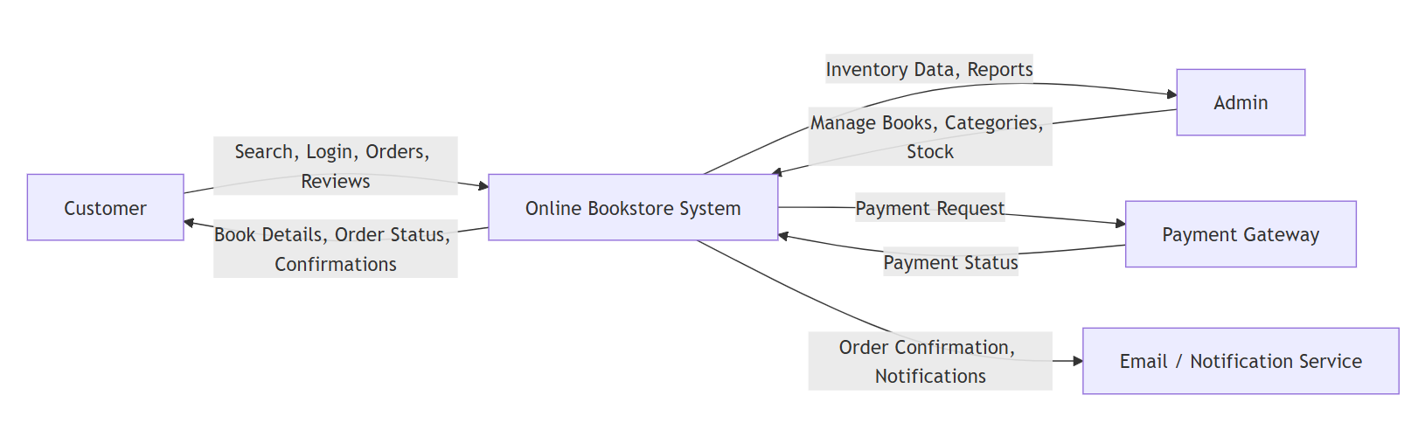

User Stories

User Story Table – Freelance Finder

User Type | Functional Requirement (Epic) | User Story / Task | Acceptance Criteria | Priority | Release
Customer | Book Browsing | As a customer, I can search and filter books by genre, author, and rating. | Search returns relevant filtered results. | High | Sprint-1
Customer | Wishlist | As a customer, I can add books to my wishlist for later purchase. | Wishlist items are stored and retrievable. | Medium | Sprint-1
Customer | Shopping Cart | As a customer, I can add books to my cart and proceed to checkout. | Cart stores selected items and reflects price & quantity. | High | Sprint-2
Customer | Checkout & Order | As a customer, I can place an order and make secure payment. | Order stored, payment processed, and order receipt generated. | High | Sprint-2
Customer | Review System | As a customer, I can leave ratings and reviews after purchase. | Reviews appear on the book detail page. | Medium | Sprint-3
Admin | Book Inventory | As an admin, I can add, update, or delete book details. | CRUD actions save correctly in database. | High | Sprint-1
Admin | Category Management | As an admin, I can create and manage book categories and genres. | Category appears in filters and listings. | Medium | Sprint-2
Admin | Order Management | As an admin, I can view and track customer orders. | Orders visible with status and history. | Medium | Sprint-3
User | Authentication | As a user, I can register, login, and access a personalized dashboard. | Authentication works and session is maintained. | High | Sprint-1

